Tomeka Pena
06/25/2026
Western Governors University
Weather-Driven Supply Chain Delay Analysis and Risk Assessment
D610 Data Engineering Capstone

A. Research Question
To what extent do weather conditions, including average temperature, precipitation, and wind speed, influence shipment delay risk within U.S. supply chain operations?

The purpose of this study was to answer this research question by integrating shipment data from DataCo SMART Supply Chain for Big Data Analysis (Tiwari, n.d.) with historical weather observations obtained from the Open-Meteo API (Open-Meteo, n.d.). The integrated dataset was analyzed using descriptive statistics, Pearson correlation analysis, and a chi-square test of independence to evaluate whether weather conditions were associated with shipment delays.

Justification
Shipment delays can negatively affect customer satisfaction, operational efficiency, and overall supply chain performance. Weather is frequently identified as a potential cause of transportation disruptions; however, its actual influence may vary depending on geographic location, transportation infrastructure, and operational practices. Determining whether weather conditions significantly contribute to shipment delays can help organizations better understand operational risk and support more informed logistics planning, scheduling, and resource allocation. This study provides a data-driven evaluation of whether weather variables demonstrate measurable relationships with shipment performance.

Context
This study analyzed shipment records from the United States between April and August 2016. To keep the project focused while maintaining meaningful geographic coverage, the analysis was limited to the eight states with the highest shipment volume in the dataset: California, New York, Texas, Pennsylvania, Washington, Illinois, Ohio, and Florida. Historical weather observations for these states were retrieved from the Open-Meteo API and integrated with shipment records through a structured ETL process using Python, Pandas, and SQLite. The final integrated dataset contained 16,143 shipment records and 1,224 weather observations, providing a unified dataset for descriptive and statistical analysis.

Hypotheses
Null Hypothesis (H₀):
Weather conditions do not have a statistically significant relationship with shipment delay risk.
Alternative Hypothesis (H₁):
Weather conditions have a statistically significant relationship with shipment delay risk.
B. Data Collection
Data for this study was collected from two publicly available sources. Shipment data was obtained from the DataCo Supply Chain Dataset available through Kaggle. This dataset contains order, shipping, delivery, product, and customer information related to supply chain operations. Historical weather data was collected using the Open-Meteo API, which provides free access to archived weather observations (Open-Meteo, n.d.). The weather dataset included daily measurements of maximum and minimum temperature, precipitation, and wind speed for representative locations within each of the eight selected states.
The data collection process began by extracting shipment records from the DataCo Supply Chain Dataset and filtering the records to include only shipments associated with the eight states that contained the highest shipment volumes. Historical weather observations were then requested from the Open-Meteo API for the same time period represented in the shipment dataset. The weather data was returned in JSON format and converted into a structured tabular dataset using Python and Pandas to prepare it for integration with the shipment data.
One advantage of the data collection methodology was the use of publicly available data sources, which allowed the project to be completed without incurring any costs while providing a large volume of real-world data. The combined datasets supplied sufficient records to support meaningful analysis while demonstrating core data engineering processes, including data extraction, transformation, loading, and data integration. One limitation of the data collection methodology was that the weather data represented a single reference location within each state. As a result, localized weather conditions occurring elsewhere within a state were not captured. Additionally, the weather observations represented conditions at a fixed location rather than along the complete shipment route. Consequently, the analysis may not fully represent the weather conditions experienced throughout a shipment's transportation path.
Additionally, a challenge encountered during data collection involved aligning shipment records with historical weather observations. Because the shipment and weather data originated from different sources and formats, the dates and geographic identifiers required standardization before the datasets could be integrated. This challenge was addressed through data cleaning and transformation processes performed in Python using Pandas, ensuring that shipment dates and state names were formatted consistently across both datasets prior to integration.

C. Data Extraction and Preparation
The data extraction and preparation process was completed using Python, Pandas, SQLite, and the Open-Meteo API. These tools were selected because they provide a cost-effective and efficient environment for performing data engineering tasks, including data extraction, transformation, loading (ETL), and integration. The shipment dataset was initially loaded into a Jupyter Notebook where exploratory data analysis was conducted to identify data quality issues, evaluate record distributions, and determine the states with the highest shipment volumes for inclusion in the study. The top 8 states were chosen because they consisted of 16,143 records which accounted for 65% of the overall dataset and included states from multiple regions.
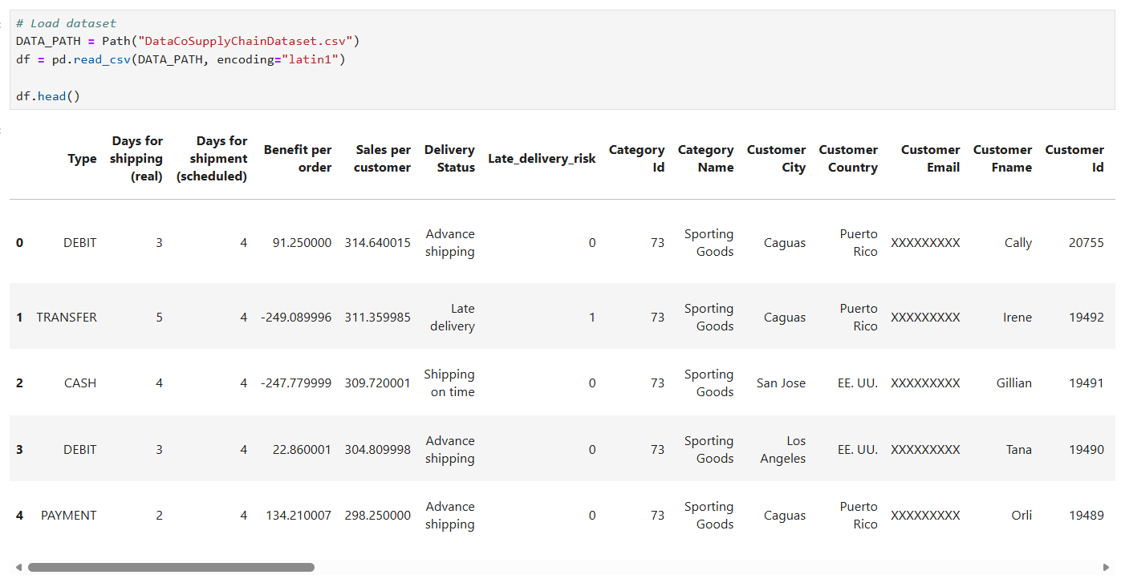
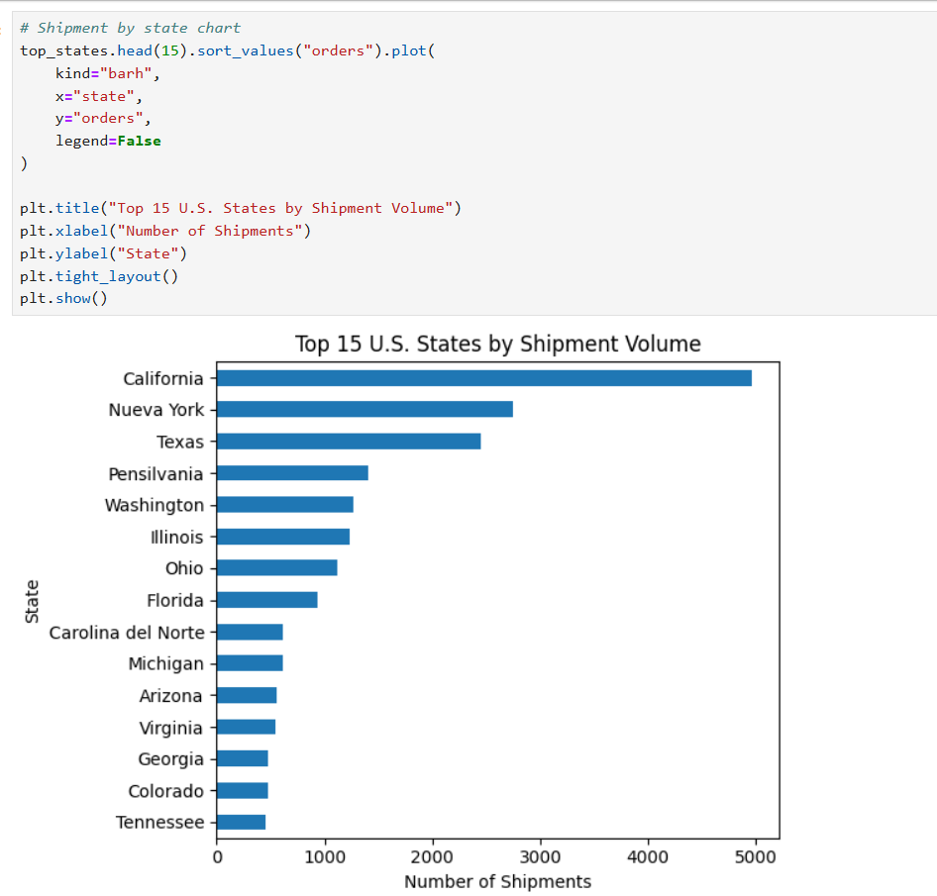
The shipment data was then cleaned and transformed using Pandas. The data preparation process included selecting only the variables required for the analysis, removing unnecessary columns, converting date fields into standardized datetime formats, verifying data types, and confirming that the cleaned dataset contained no missing values. Additional preprocessing steps included creating derived variables such as shipment delay days and late delivery risk while standardizing the data to support consistent integration with historical weather observations. These transformations improved data quality and ensured the shipment records were accurate, complete, and analysis-ready. The cleaned dataset was then exported as a CSV file and used as the input for the remaining ETL process, including integration with the weather data and loading into SQLite for validation and analysis.
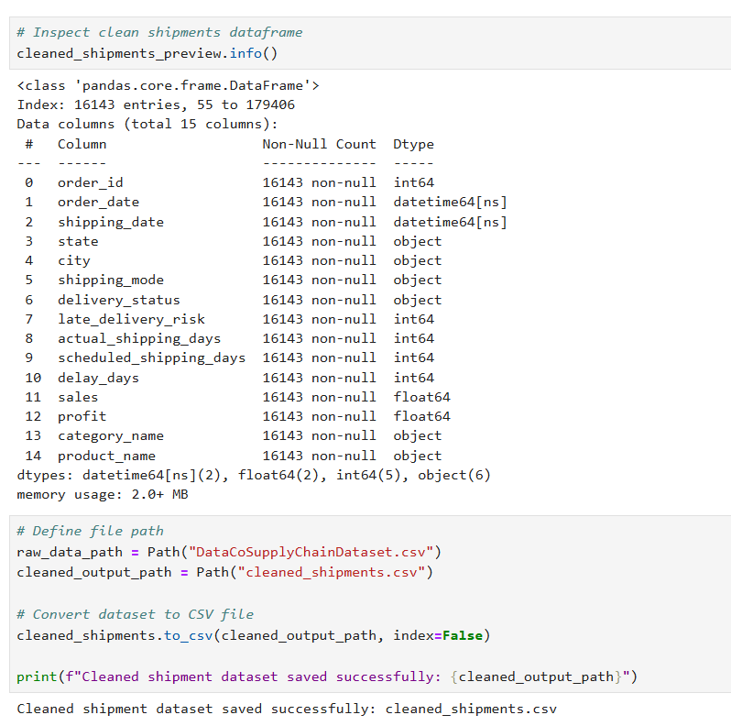

SQLite and Database Creation
Following preprocessing, a local SQLite database was created to store the transformed shipment and weather data in a structured relational format. SQLite was selected because it is a lightweight, serverless relational database management system that can be implemented locally without requiring additional software or cloud infrastructure. Using a relational database also mirrors common data engineering workflows, where transformed data is stored before being queried, validated, and analyzed.
The database schema consisted of three primary tables: shipments, weather, and shipment_weather. The shipments table stored the cleaned shipment records, while the weather table contained the historical weather observations extracted from the Open-Meteo API. The shipment_weather table served as the integrated analytical dataset by combining shipment information with the corresponding weather observations using state and shipment date as the matching keys. Separating the data into logical tables improved organization, reduced redundancy, and simplified validation throughout the ETL process.
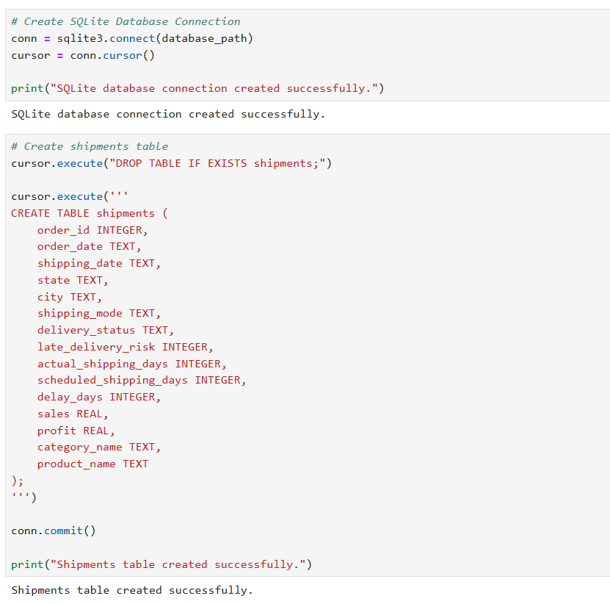
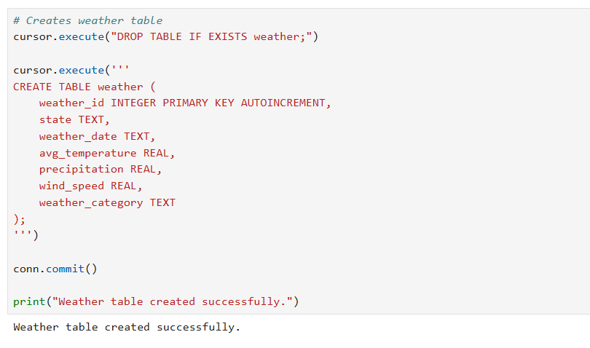
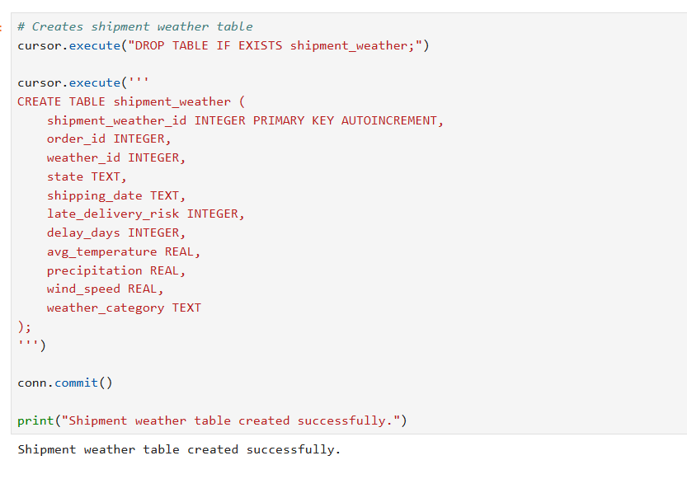
After the database schema was created, the cleaned shipment dataset was loaded into the shipments table using Pandas. Validation queries were then executed to confirm that all 16,143 records were successfully imported into the database. Additional SQL queries were used to preview the imported records, verify the table structure, and confirm that the shipment, weather, and integrated shipment-weather tables had been created successfully. These validation procedures ensured that the database accurately represented the transformed data before integration and statistical analysis were performed.
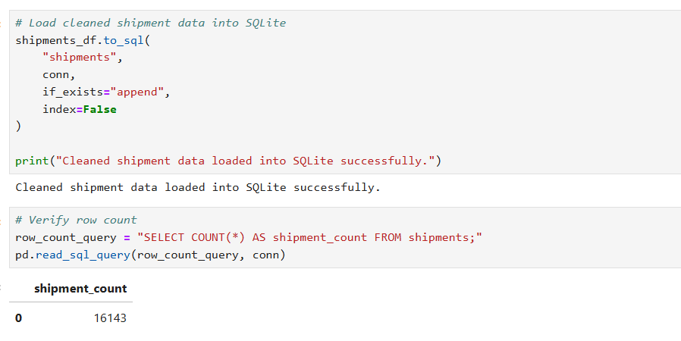

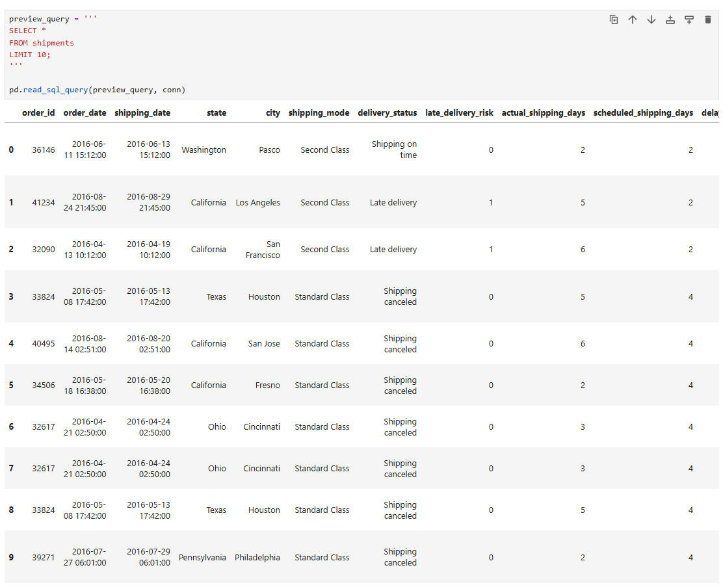
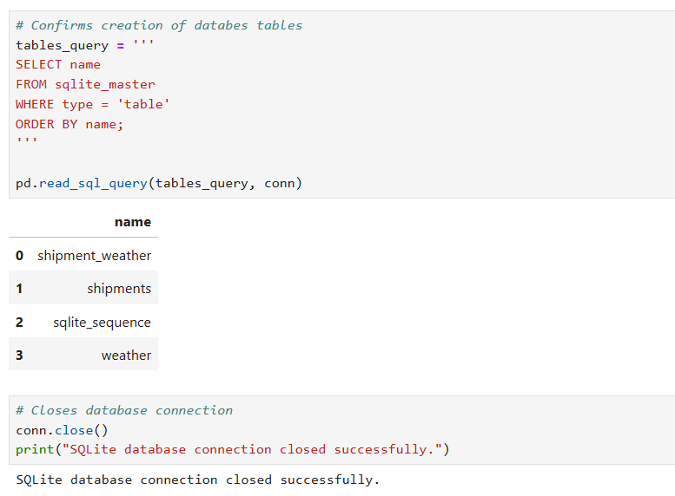

Weather Data Extraction
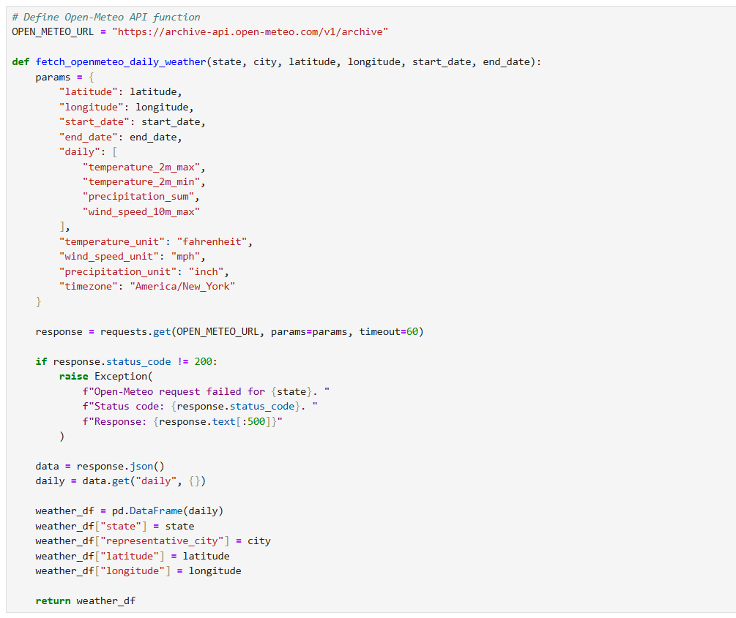
Historical weather observations were collected using the Open-Meteo Historical Weather API. A reusable Python function was developed to automate API requests by accepting the state name, representative city, geographic coordinates, and date range as input parameters. The function submitted requests for daily maximum temperature, minimum temperature, precipitation, and maximum wind speed while specifying standardized measurement units. Error handling was incorporated to verify successful API responses before the returned JSON data was converted into a Pandas DataFrame. Additional location attributes, including the state name, representative city, latitude, and longitude, were appended to each weather record to support downstream integration with the shipment dataset.
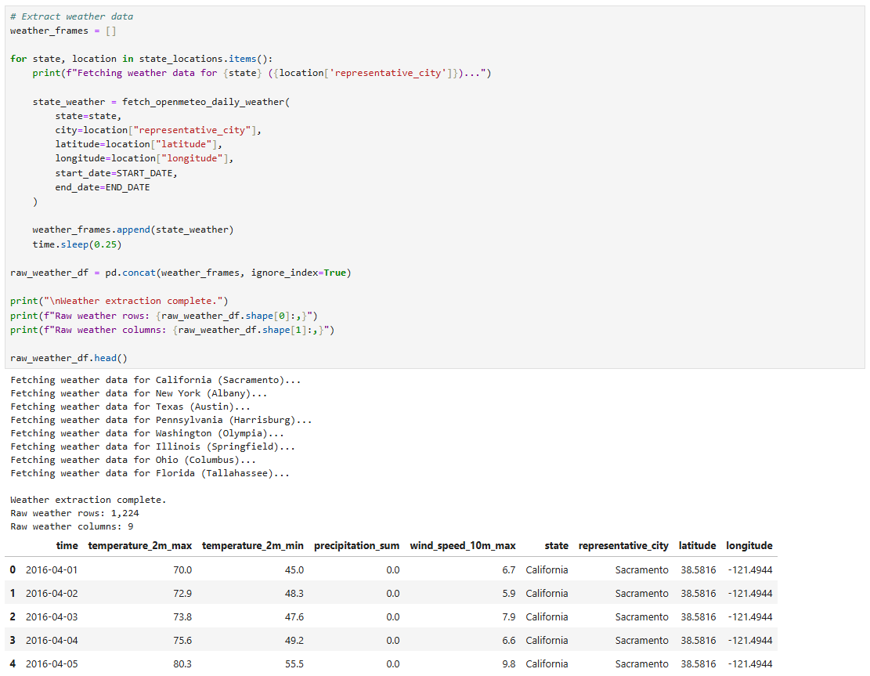
The weather extraction function was executed for each of the eight selected states, resulting in 1,224 daily weather records. The extracted data included maximum temperature, minimum temperature, precipitation, and wind speed for each representative city during the study period.
After extraction, the weather dataset was standardized by renaming columns, converting dates into a consistent format, and calculating the average daily temperature from the recorded maximum and minimum temperatures. A weather category variable was also created to classify observations into conditions such as Normal, Rain, Heavy Rain, Extreme Heat, Freezing, and High Wind. Finally, only the variables required for integration and analysis were retained in the final weather dataset.
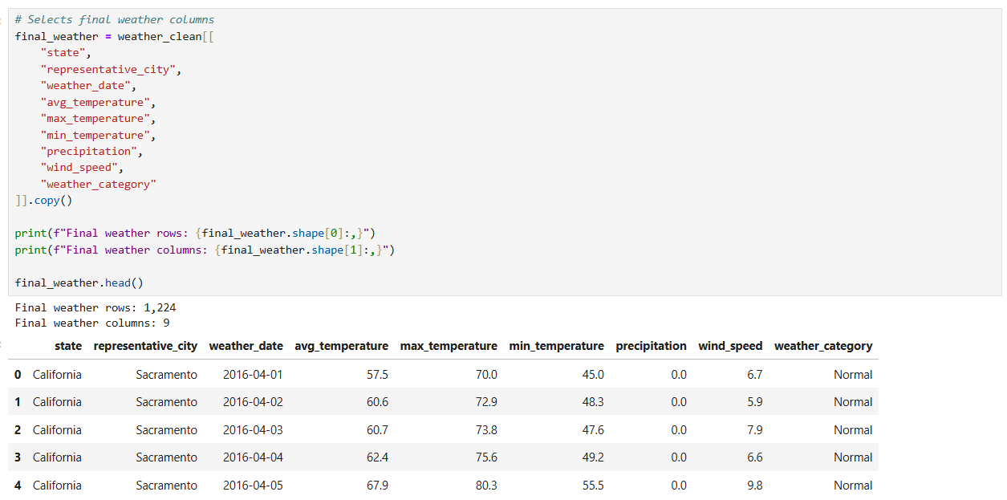
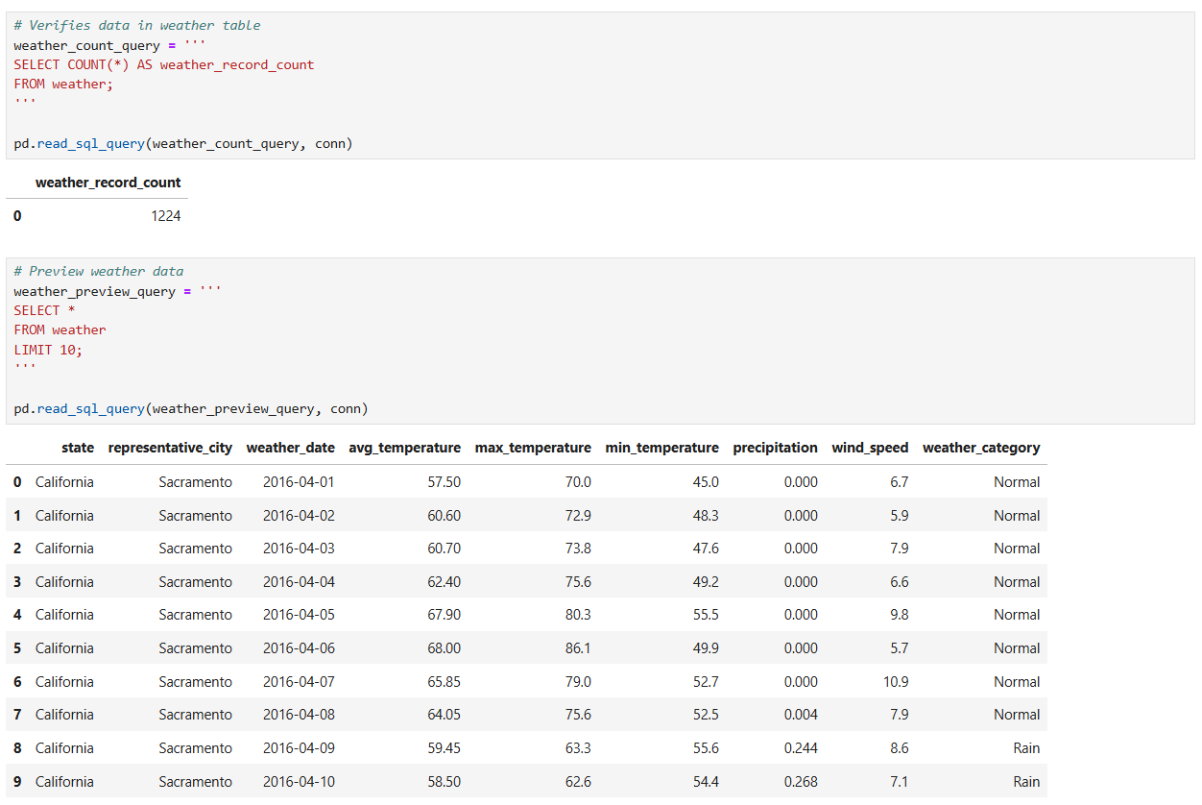
The finalized weather dataset was exported as a CSV file and loaded into the SQLite database to support relational storage and integration with the shipment records. Validation queries were executed after loading to confirm that all 1,224 weather records were successfully imported into the weather table. Sample SQL queries were then used to preview the imported records and verify that the weather attributes, data types, and calculated variables were stored correctly. These validation procedures confirmed that the weather dataset was complete and accurately prepared for integration with the shipment data during the final stage of the ETL process.
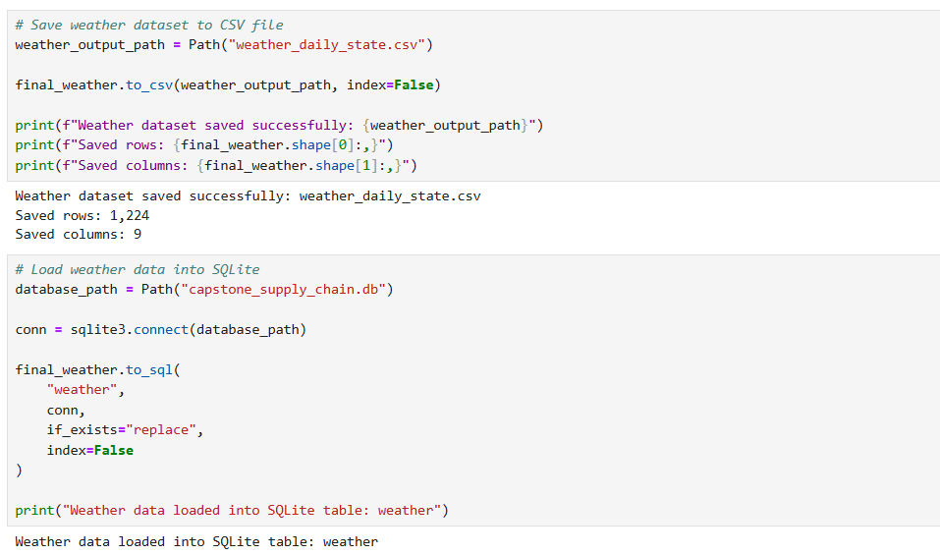

Shipment and Weather Integration
After the shipment and weather datasets were validated independently, they were integrated into a single analytical dataset using a SQL query executed against the SQLite database. A LEFT JOIN was performed between the shipments and weather tables using the shipment state and shipping date as the matching keys. This approach preserved all shipment records while appending the corresponding historical weather observations for each shipment. The integrated dataset contained 16,143 records and 22 variables, providing a complete dataset for statistical analysis and dashboard development.
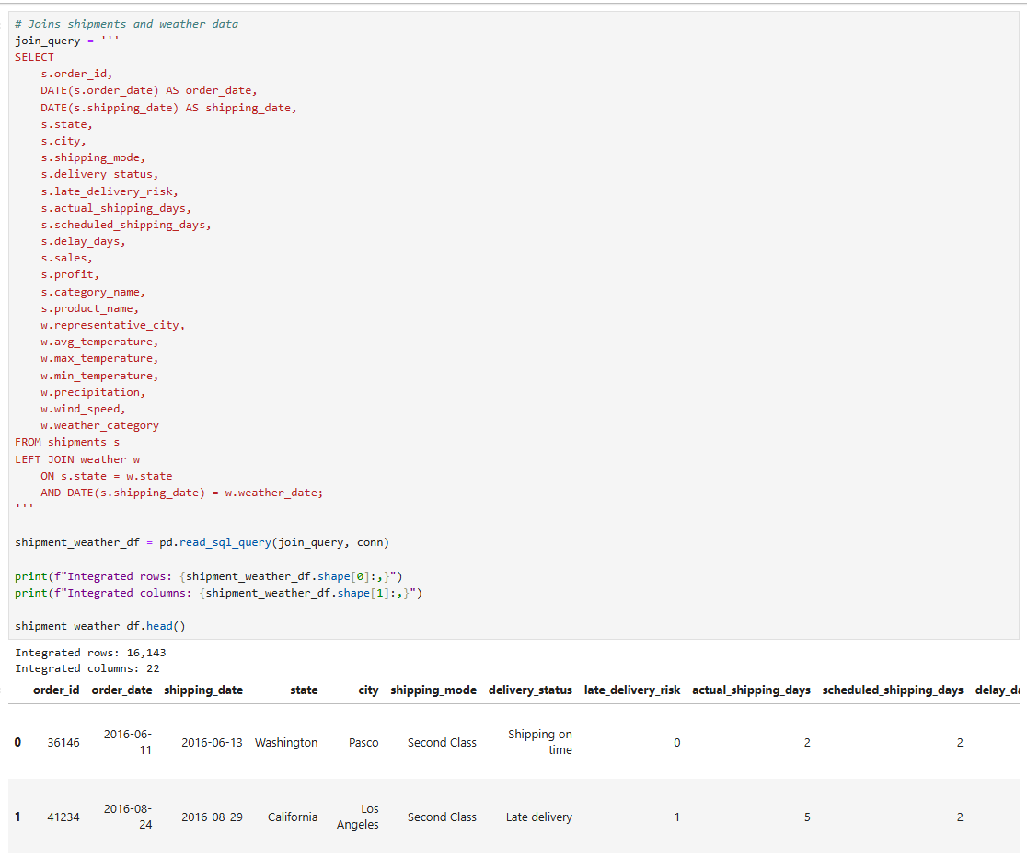

Following integration, multiple validation procedures were performed to verify the quality and completeness of the combined dataset. The integrated table was examined to confirm the expected number of records and variables, while missing value checks verified that all weather attributes were successfully matched to the shipment records. The weather category distribution was also reviewed to ensure that each shipment was assigned an appropriate weather classification. Finally, a match rate calculation confirmed that all 16,143 shipment records were successfully linked with historical weather observations, resulting in a 100% integration success rate. These validation procedures confirmed that the integrated dataset was complete and ready for statistical analysis.
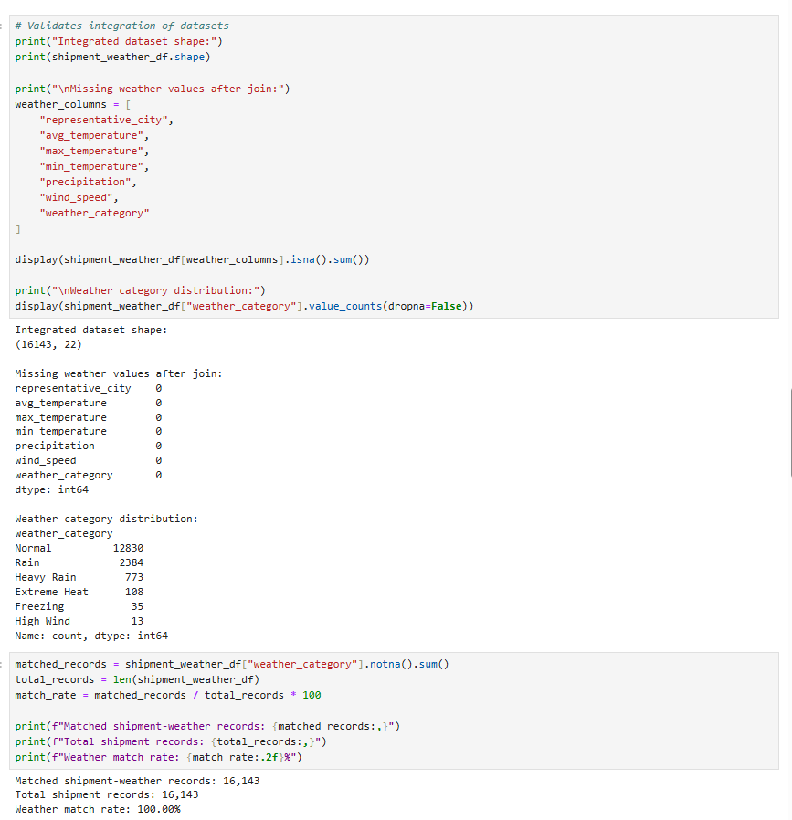
After the shipment and weather datasets were successfully integrated, the combined dataset was written back to the SQLite database as the shipment_weather table. Storing the integrated dataset in a dedicated table provided a centralized source for statistical analysis and dashboard development while preserving the results of the ETL process. Validation queries confirmed that all 16,143 integrated records were successfully loaded into the database, and sample SQL queries were executed to verify the structure and contents of the final analytical dataset. This final validation ensured that the integrated shipment-weather table was complete and ready for downstream analysis.
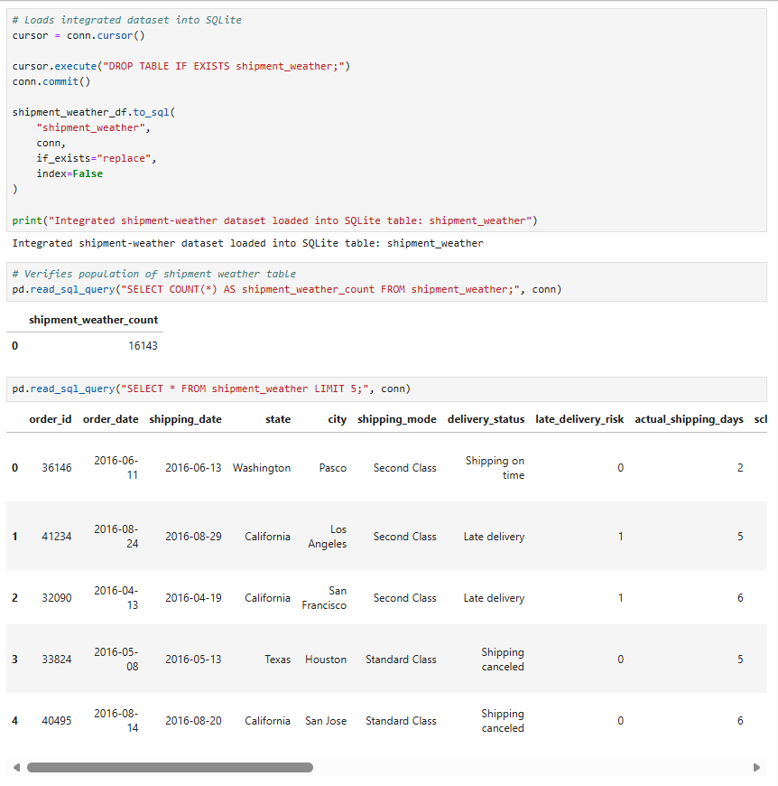

Tools and Techniques
Python and the Pandas library were selected because they provide a flexible environment for performing data engineering tasks such as data extraction, cleaning, transformation, and integration. Pandas simplified the manipulation of structured datasets by supporting efficient filtering, column selection, date formatting, and creation of derived variables required for the analysis. SQLite was selected as the project's relational database because it is lightweight, serverless, and easily integrated with Python, making it well suited for storing, validating, and querying the transformed shipment and weather data without requiring additional database infrastructure. One advantage of using these tools is their ability to support the complete ETL workflow, from acquiring raw data through preparing an analysis-ready dataset. One disadvantage is that each stage of the workflow depends on the successful completion of the previous step, making data validation essential throughout the extraction, transformation, and loading process to ensure the integrity of the final dataset.

D. Analysis
The analysis phase focused on determining whether weather conditions were associated with shipment delays after the shipment and weather datasets were integrated. Descriptive summary statistics were first generated to examine shipment performance across weather categories and states before applying statistical techniques to evaluate relationships between weather variables and shipment delay metrics. The primary variables examined included average temperature, precipitation, wind speed, weather category, delay days, and late delivery risk.
The first analysis summarized shipment performance by weather category. Shipment records were grouped into the categories Normal, Rain, Heavy Rain, Extreme Heat, Freezing, and High Wind. For each category, total shipments, late delivery rate, average delay days, average precipitation, average wind speed, and average temperature were calculated. The results showed that late delivery rates were relatively consistent across all weather conditions, ranging from 54.44% under Normal conditions to 61.54% during High Wind conditions. Although slightly higher late delivery rates were observed during High Wind and Freezing conditions, these categories contained relatively few shipment records compared to the remaining weather categories. Overall, the descriptive analysis suggested that shipment performance remained relatively consistent regardless of weather condition.
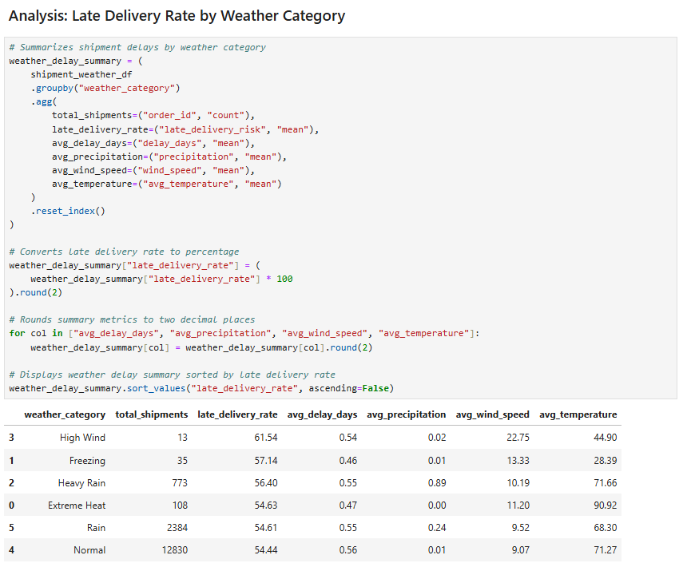
Shipment performance was also summarized at the state level to evaluate whether delay patterns varied geographically. The overall state summary showed that New York recorded the highest late delivery rate at 57.90%, followed by Texas (56.66%) and Illinois (55.21%). Pennsylvania had the lowest observed late delivery rate among the selected states at 50.21%. Additional summaries comparing weather categories within each state showed similar patterns, with only modest differences in late delivery rates across weather conditions. These descriptive summaries provided additional context before conducting statistical analyses and suggested that weather conditions alone were unlikely to explain differences in shipment performance.

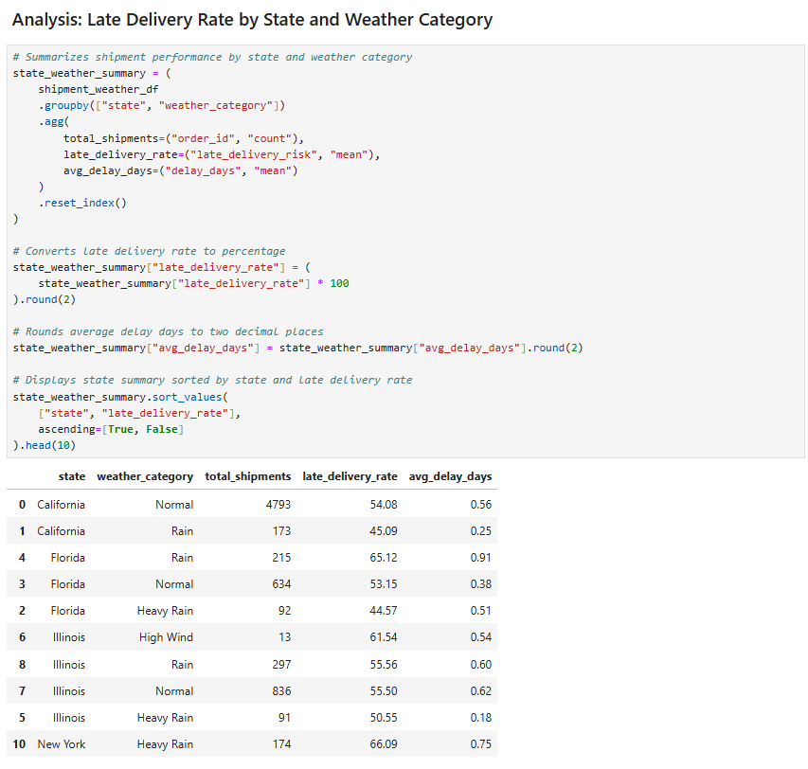
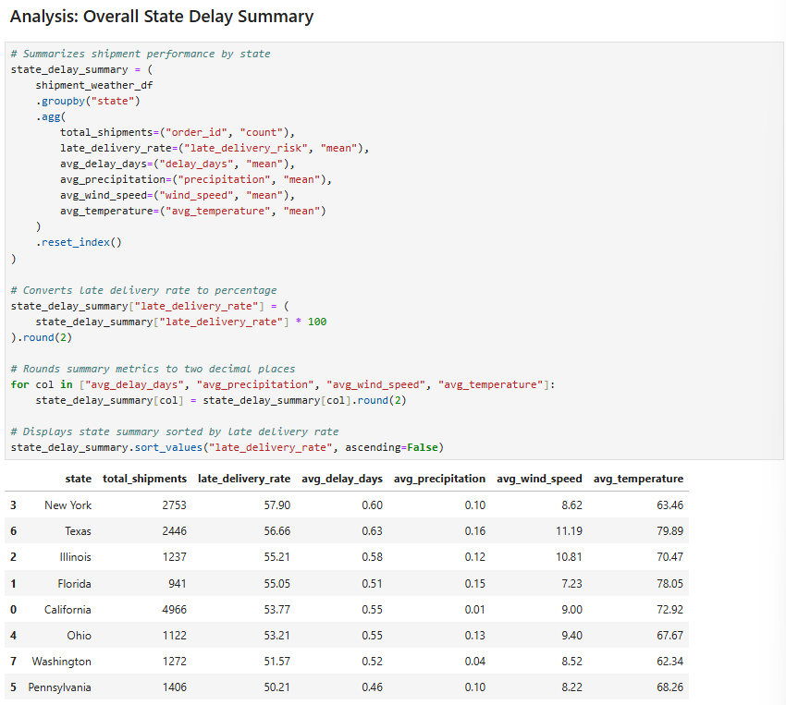
Correlation analysis was then performed to evaluate the strength and direction of relationships between weather variables and shipment delay metrics. Pearson correlation coefficients were calculated between average temperature, precipitation, wind speed, delay days, and late delivery risk. Pearson correlation was selected because it is a widely accepted statistical technique for measuring linear relationships between continuous numerical variables.
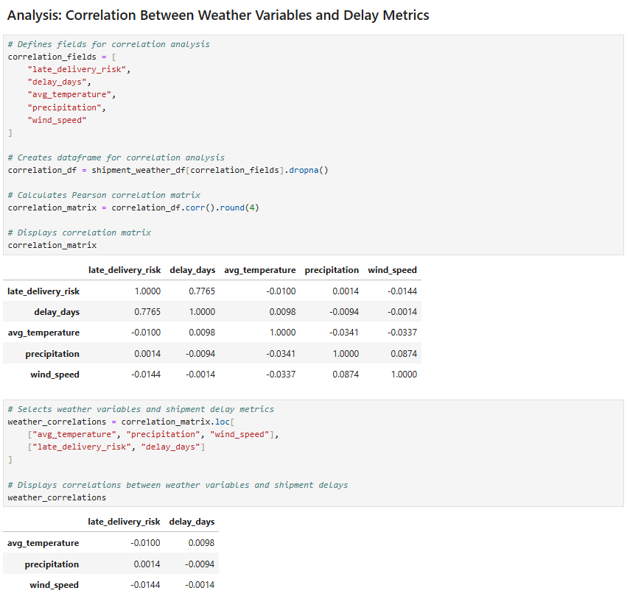
The correlation analysis produced coefficients ranging from -0.0144 to 0.0098. Average temperature showed a correlation of -0.0100 with late delivery risk and 0.0098 with delay days. Precipitation showed a correlation of 0.0014 with late delivery risk and -0.0094 with delay days. Wind speed showed a correlation of -0.0144 with late delivery risk and -0.0014 with delay days. Because all correlation coefficients were very close to zero, the analysis indicated little to no linear relationship between the weather variables and shipment delay metrics.
A chi-square test of independence was then performed to determine whether weather category and late delivery risk were statistically associated. The chi-square test was selected because both variables are categorical in nature. Weather category represents grouped weather conditions, while late delivery risk is a binary classification indicating whether a shipment was at risk of being delivered late.
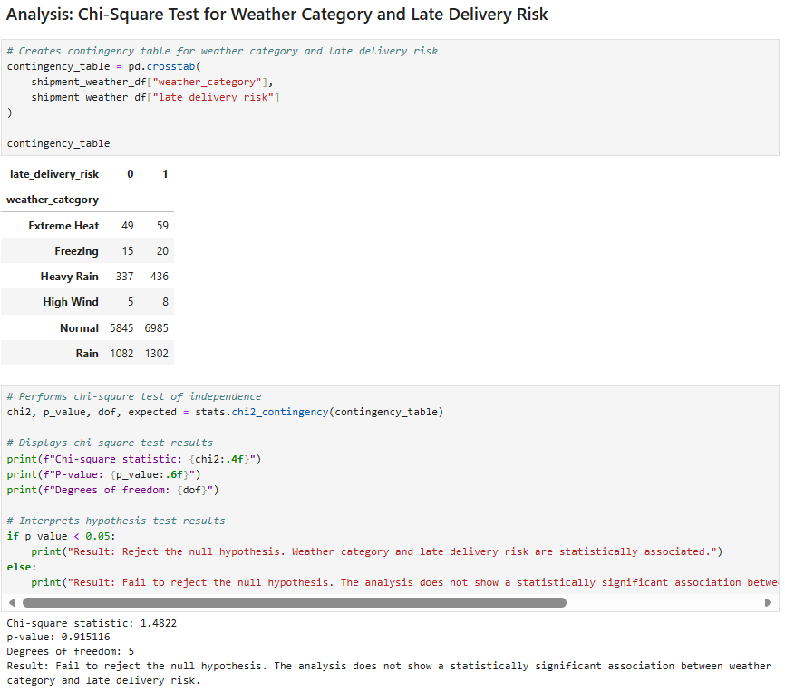
The chi-square test produced a chi-square statistic of 1.4822 with a p-value of 0.915116 and five degrees of freedom. Because the p-value exceeded the significance level of 0.05, the null hypothesis could not be rejected. These results indicate that the analysis did not identify a statistically significant association between weather category and late delivery risk within the dataset. The findings from the chi-square test support the correlation analysis, with both techniques indicating that weather variables did not demonstrate a meaningful relationship with shipment delays during the study period.

Advantages and Disadvantages
One advantage of the selected analytical techniques is that they provide objective and interpretable measures for evaluating relationships within the data. Descriptive summaries identify overall shipment performance trends, correlation analysis quantifies relationships between numerical variables, and the chi-square test evaluates associations between categorical variables. Together, these techniques provided complementary evidence for answering the research question. One limitation is that these methods evaluate only the variables included in the dataset and may not capture operational factors such as carrier performance, warehouse processing times, routing decisions, or traffic conditions that could also contribute to shipment delays.

E. Outcomes and Implications
The purpose of this study was to determine whether weather conditions influenced shipment delays within U.S. supply chain operations. After integrating shipment records with historical weather observations and performing descriptive and statistical analyses, the results indicated that weather conditions were not significantly associated with shipment delay risk within the dataset. Although slight differences were observed among the weather categories, the correlation analysis produced coefficients near zero, and the chi-square test failed to identify a statistically significant relationship between weather category and late delivery risk. Together, these findings indicate that the weather variables included in this study were not strong predictors of shipment delays. Findings are illustrated in the dashboard below.
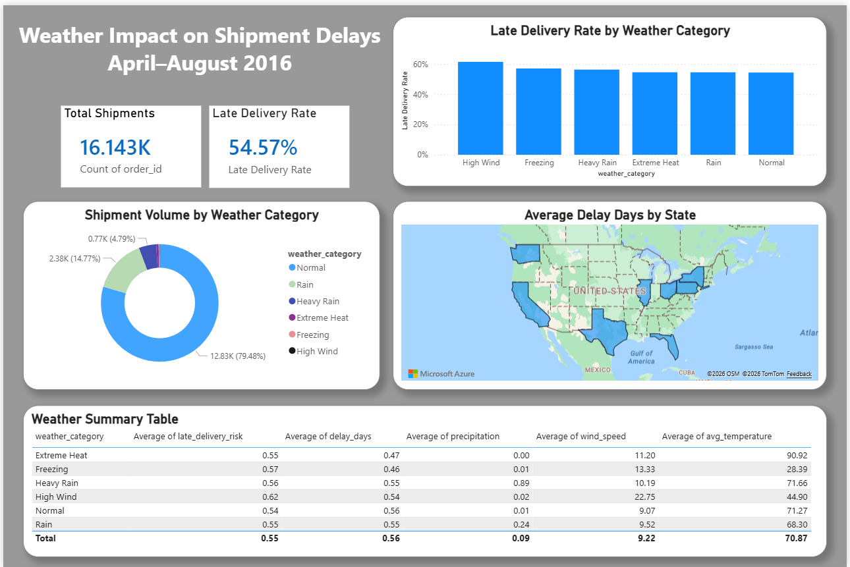
The results suggest that weather conditions, as measured in this study, were not a primary driver of shipment delays during the period examined. Although weather is commonly associated with transportation disruptions, the findings indicate that other operational factors may have had a greater influence on shipment performance. Variables such as carrier performance, warehouse processing efficiency, transportation routing decisions, staffing levels, traffic conditions, and logistics network constraints may provide stronger explanations for shipment delays than weather conditions alone.
One limitation of this study is that historical weather observations were represented using a single reference location within each selected state. While this approach provided a practical and consistent method for integrating weather data with shipment records, it may not fully capture localized weather conditions experienced throughout a shipment's transportation route. Consequently, the analysis may not reflect weather events occurring outside the selected reference locations or conditions encountered during transit.
Based on these findings, organizations should avoid assuming that weather conditions alone are a primary cause of shipment delays. Instead, logistics managers and supply chain decision-makers should investigate operational and transportation-related factors that may contribute more directly to late deliveries. Focusing improvement efforts on carrier management, routing optimization, warehouse operations, fulfillment processes, and transportation scheduling may provide greater opportunities to reduce shipment delays and improve customer service performance.
Future research could expand this study by incorporating additional logistics variables such as carrier information, transportation distance, fulfillment center locations, shipping mode, warehouse processing times, and traffic conditions. Including these operational variables may improve the ability to identify stronger predictors of shipment delays and produce more accurate predictive models. Future studies could also incorporate route-level weather observations collected throughout a shipment's transportation path rather than relying on a single representative location within each state. Evaluating the weather conditions encountered during transit may provide a more comprehensive understanding of how environmental conditions influence shipment performance and may reveal weather-related impacts that were not detectable using state-level weather observations.

References

Open-Meteo. (n.d.). Historical Weather API [Data set]. https://open-meteo.com/en/docs/historical-weather-api

Tiwari, S. (n.d.). DataCo SMART Supply Chain for Big Data Analysis [Data set]. Kaggle. https://www.kaggle.com/datasets/shashwatwork/dataco-smart-supply-chain-for-big-data-analysis

